# The Kindness Quest of Willow Wood

## Page 1: Opening Hook

In the heart of Willow Wood, where sunlight danced through the canopy like golden fireflies, lived a young squirrel named Pip. Pip was known far and wide for his bushy tail, quick wit, and boundless curiosity. On this particular morning, as the forest awoke to the melody of chirping birds and rustling leaves, Pip discovered a peculiar map tucked beneath an ancient oak tree. The map promised an adventure to find the legendary "Heart of Kindness," a mysterious treasure said to bring warmth and joy to the entire forest.  
  
---

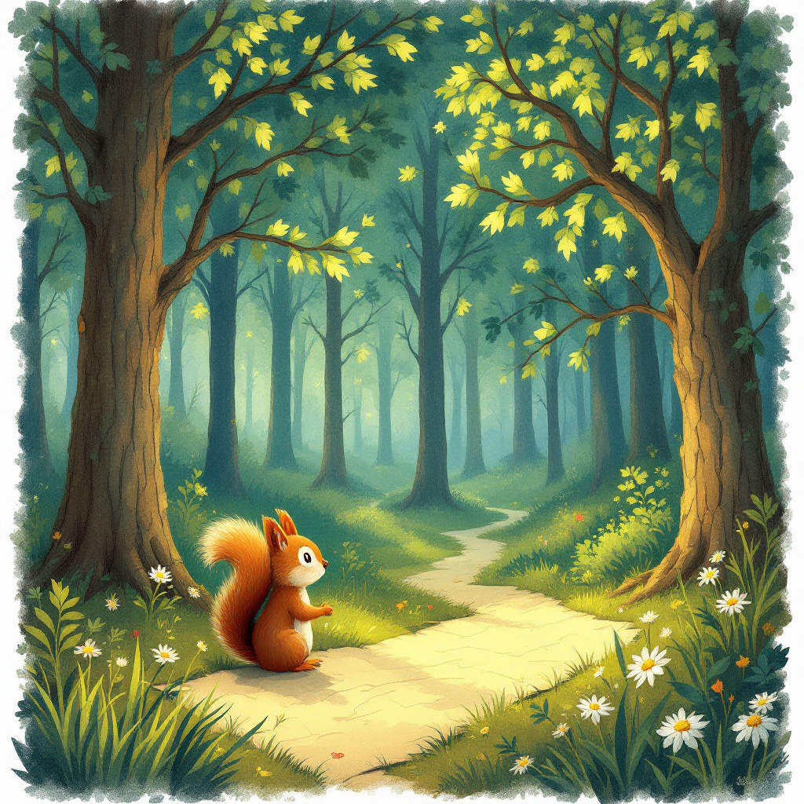

## Page 2: Character & World-Building

Willow Wood was a magical place, where the trees whispered ancient secrets and streams giggled as they tumbled over stones. Pip, with his bright eyes and adventurous spirit, was loved by all the creatures. His best friend, Luna the rabbit, was always by his side, bringing her wisdom and gentle humor. Together, they set off on the quest, the map guiding them deeper into the enchanting forest.  
  
---

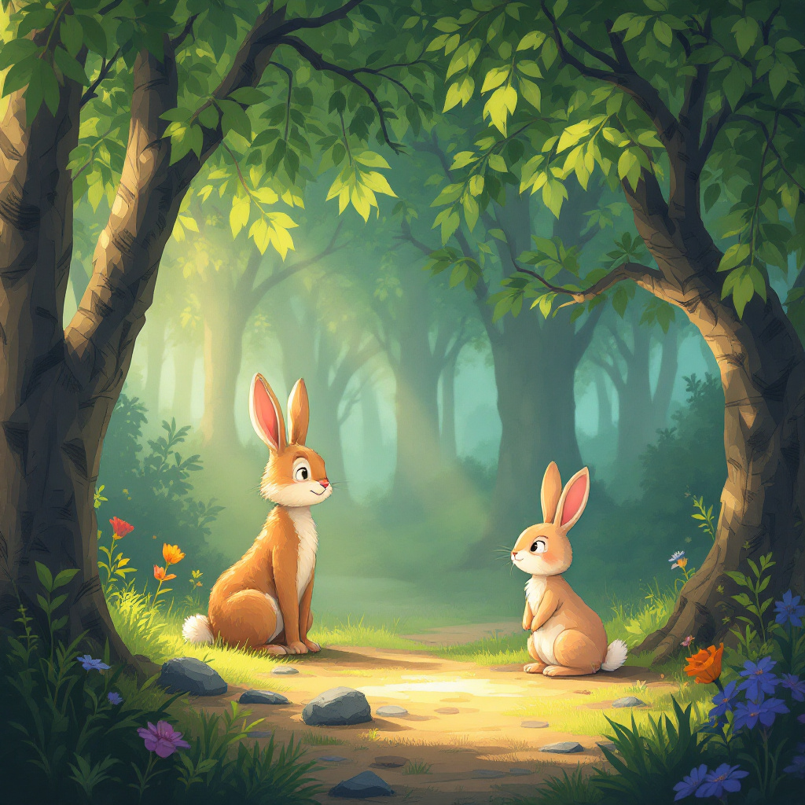

## Page 3: The First Challenge

Their first stop was the Singing Meadow, where flowers bloomed in every color of the rainbow. But the meadow was guarded by Blue, a wise old bluebird with a penchant for riddles. To pass, Pip and Luna had to solve a riddle: "What grows when you give it away?" Luna pondered, her nose twitching. Then, with a smile, she chirped, "Kindness!" Blue clapped his wings, granting them passage with a smile as warm as sunshine.  
  
---

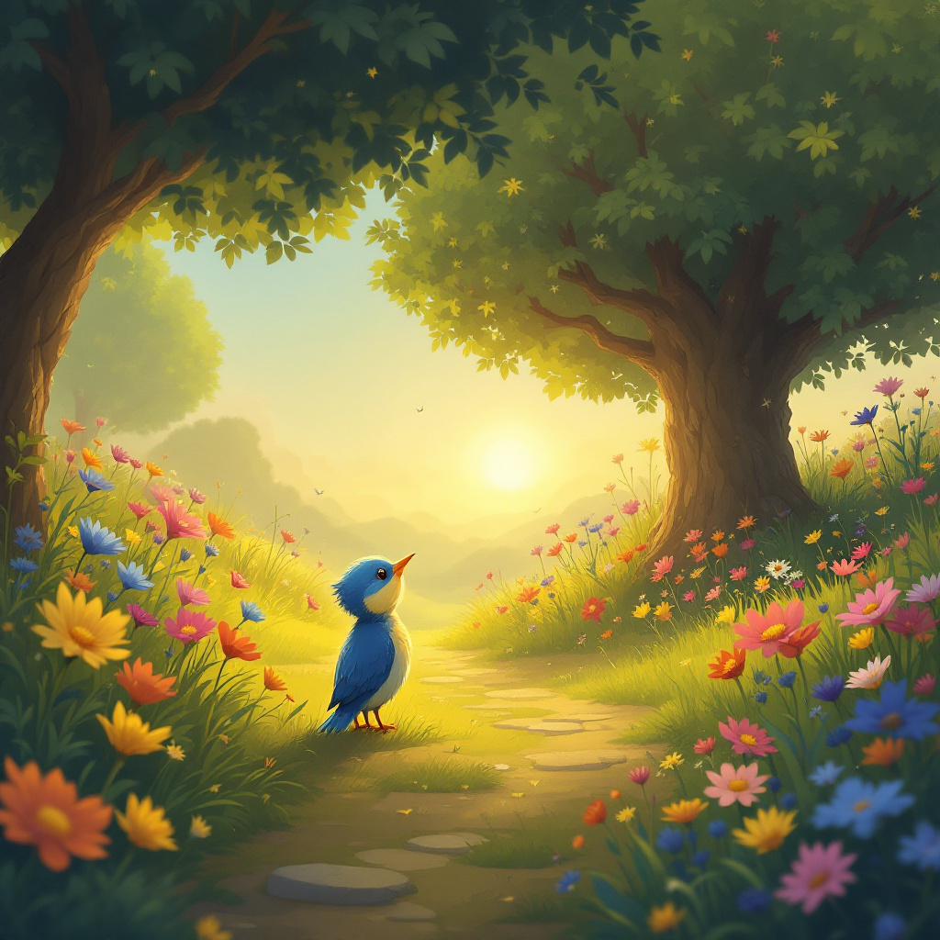

## Page 4: The River of Reflection

Next, they reached the River of Reflection, where the water mirrored their every move. A bridge of stepping stones led across, but the current was swift and strong. Pip hesitated, worried for Luna. But Luna, with a twinkle in her eye, suggested they hold paws and cross together. Their teamwork and trust made the crossing easy, teaching them the power of kindness in unity.  
  
---

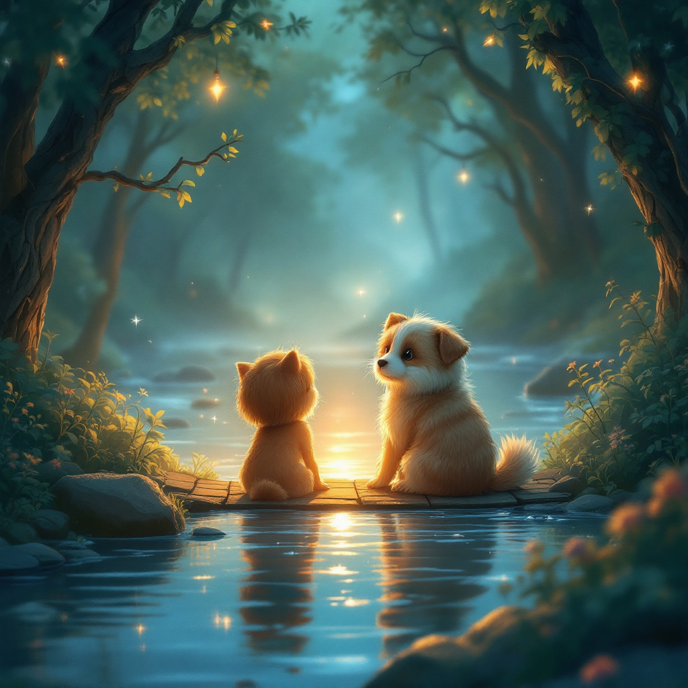

## Page 5: The Whispering Glade

In the Whispering Glade, shadows danced mysteriously, and the air was thick with secrets. Here, they met Eldra, a wise old tortoise with stories as old as the forest. Eldra shared tales of past adventurers and the importance of listening to others. Pip and Luna listened intently, learning that kindness often means lending an ear and understanding others' stories.  
  
---

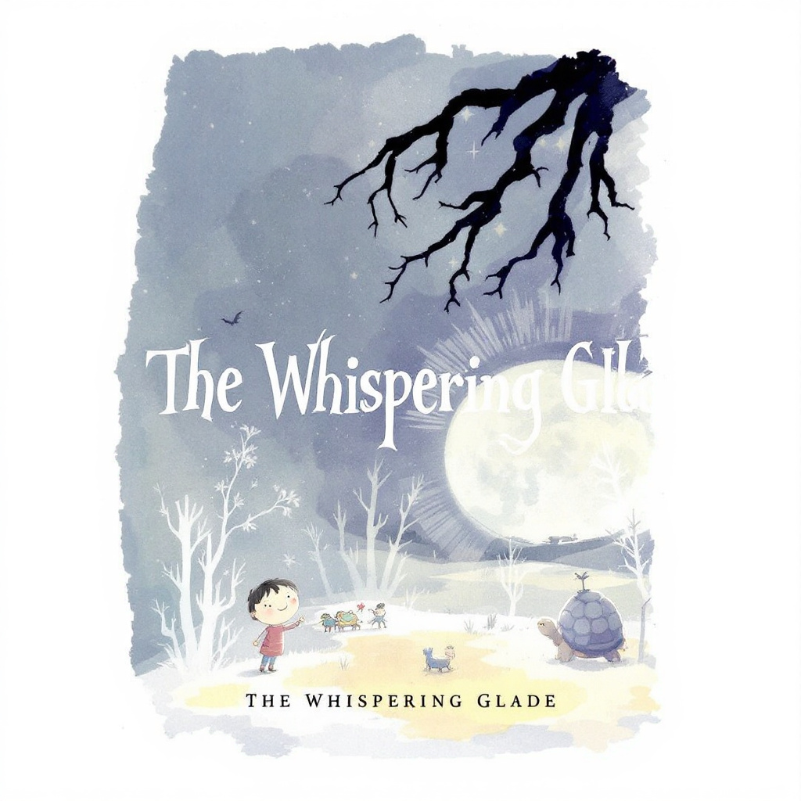

## Page 6: The Climb to Courage Peak

Their journey led them to Courage Peak, a rocky hill that seemed to touch the sky. The climb was steep and challenging. Pip felt his energy waning, but Luna, ever patient and encouraging, reminded him of the kindness they had experienced and shared. With renewed determination, they reached the top, finding strength in the kindness of words and support.  
  
---

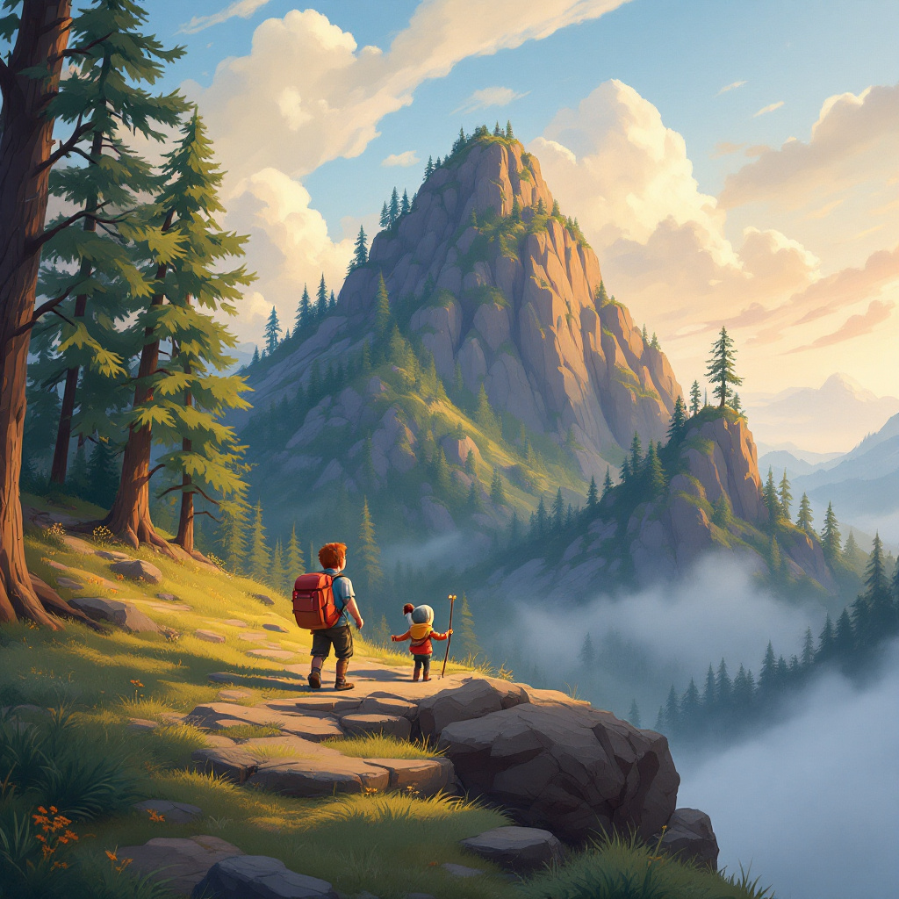

## Page 7: The Heart of Kindness

At the peak, a small, shimmering heart-shaped stone lay nestled in a bed of soft moss. As Pip and Luna touched it, the stone glowed warmly, filling the air with a gentle light. The Heart of Kindness was not a treasure to be kept, but a reminder of the kindness they had shown and received along their journey.  
  
---

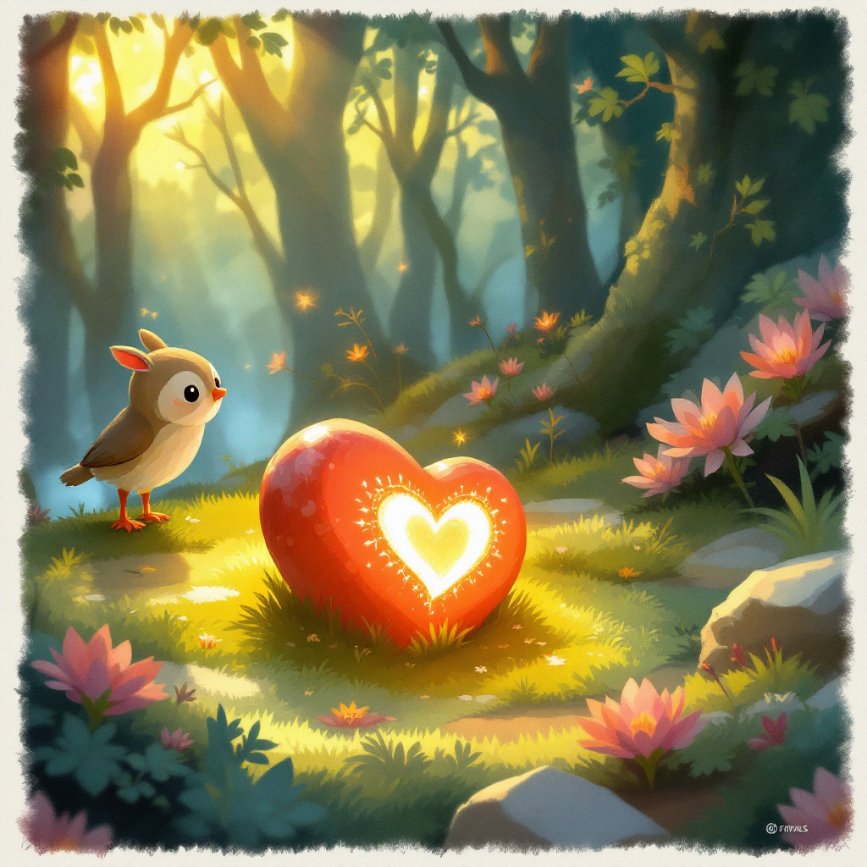

## Page 8: The Return Journey

As they descended Courage Peak, Pip and Luna felt a change within themselves, a new understanding of the forest and its inhabitants. They realized that the true treasure was not the stone, but the kindness they had spread and the friendships they had strengthened.  
  
---

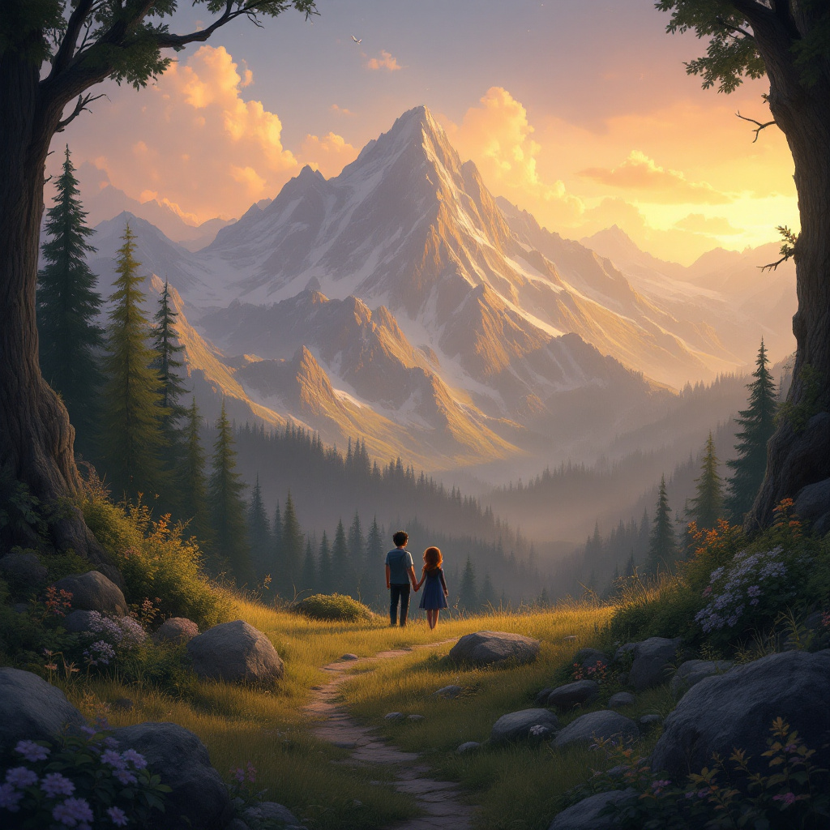

## Page 9: Sharing the Lesson

Back in Willow Wood, Pip and Luna shared their adventure with the other animals, inspiring acts of kindness throughout the forest. They planted the Heart of Kindness beneath the ancient oak, where it would continue to radiate warmth and joy.  
  
---

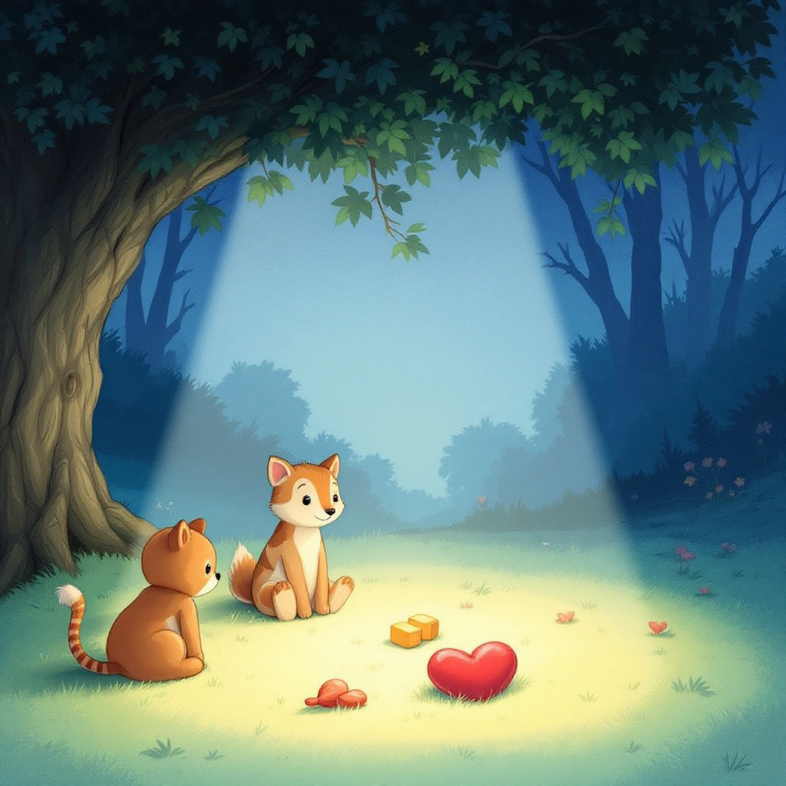

## Page 10: Ending

As the sun set, casting a golden glow over Willow Wood, Pip and Luna sat together, their hearts full of the day’s adventures. They knew that kindness was not just a treasure to be found, but a gift to be shared. With a contented sigh, they drifted into dreams, knowing that their kindness had made Willow Wood a brighter, happier place.  
  
---  
  
And so, dear reader, remember that kindness, like a seed, grows when you give it away, creating a world as magical as Willow Wood. Sweet dreams. 🌙

